**API TESTING FULL COURSE- 10 Sessions**

**Session-1**

1) What is Client & server?

2) Client-server architecture

3) What is an API?

4) What is API Testing? Why it is needed?

5) Types of an API - SOAP & Rest

6) API Vs Webservice

7) Rest API methods

8) http Vs https

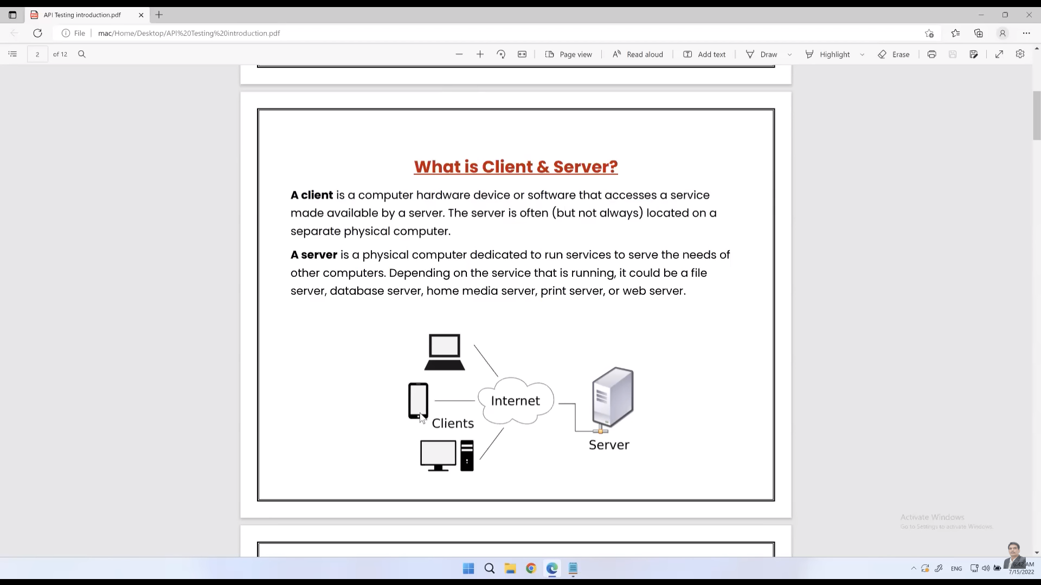

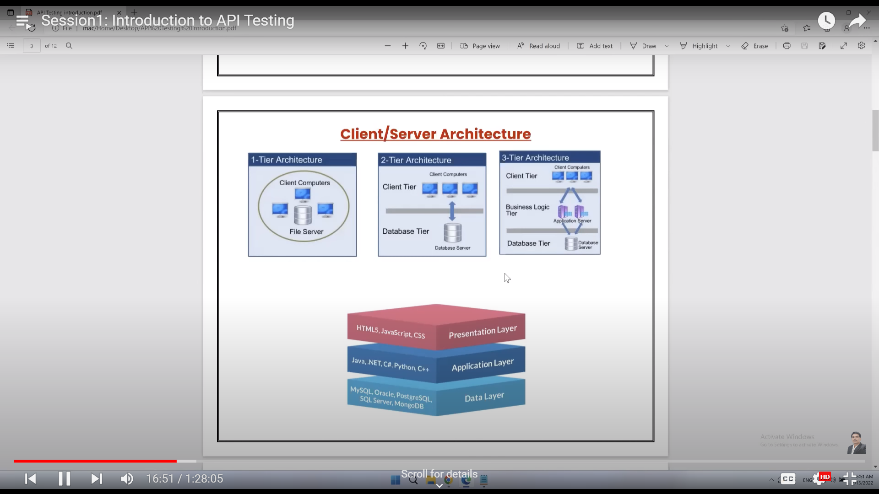

Examples

1 -tier -> Saving the file on same machine

2- tier-> banking system. Where multiple clients are accessing the same database

3-tier-> Client-server where we have 3 layers to communicate.

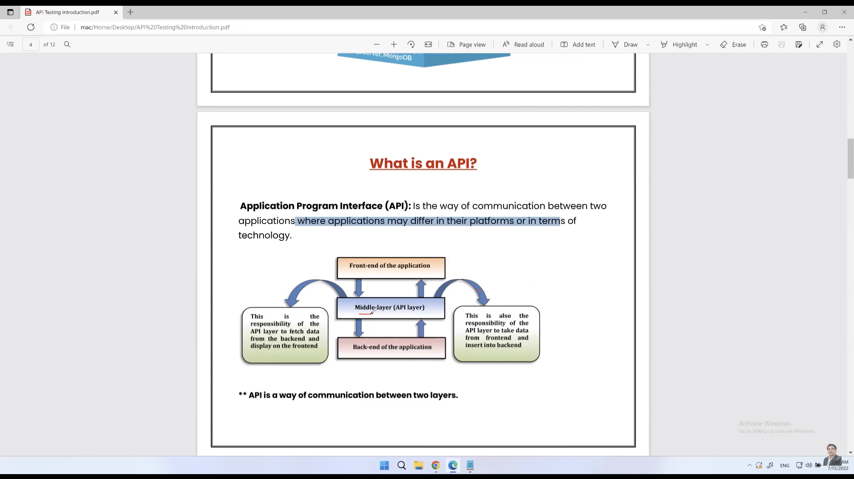

API -> Resides in middle layer and act as a middle layer to communicate between front end and backend.

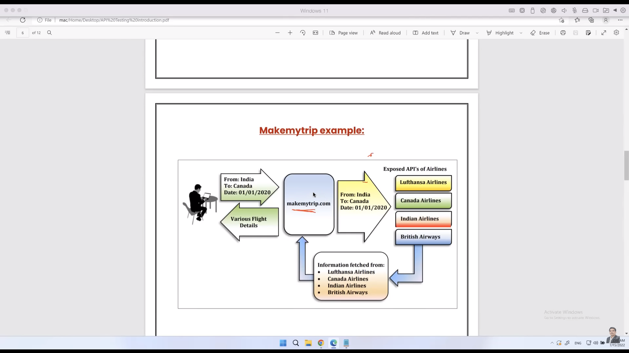

API over http known as webservices. All webservices are API but all API are not webservices (Until and unless we upload them on internet). Technically webservices and API are same.

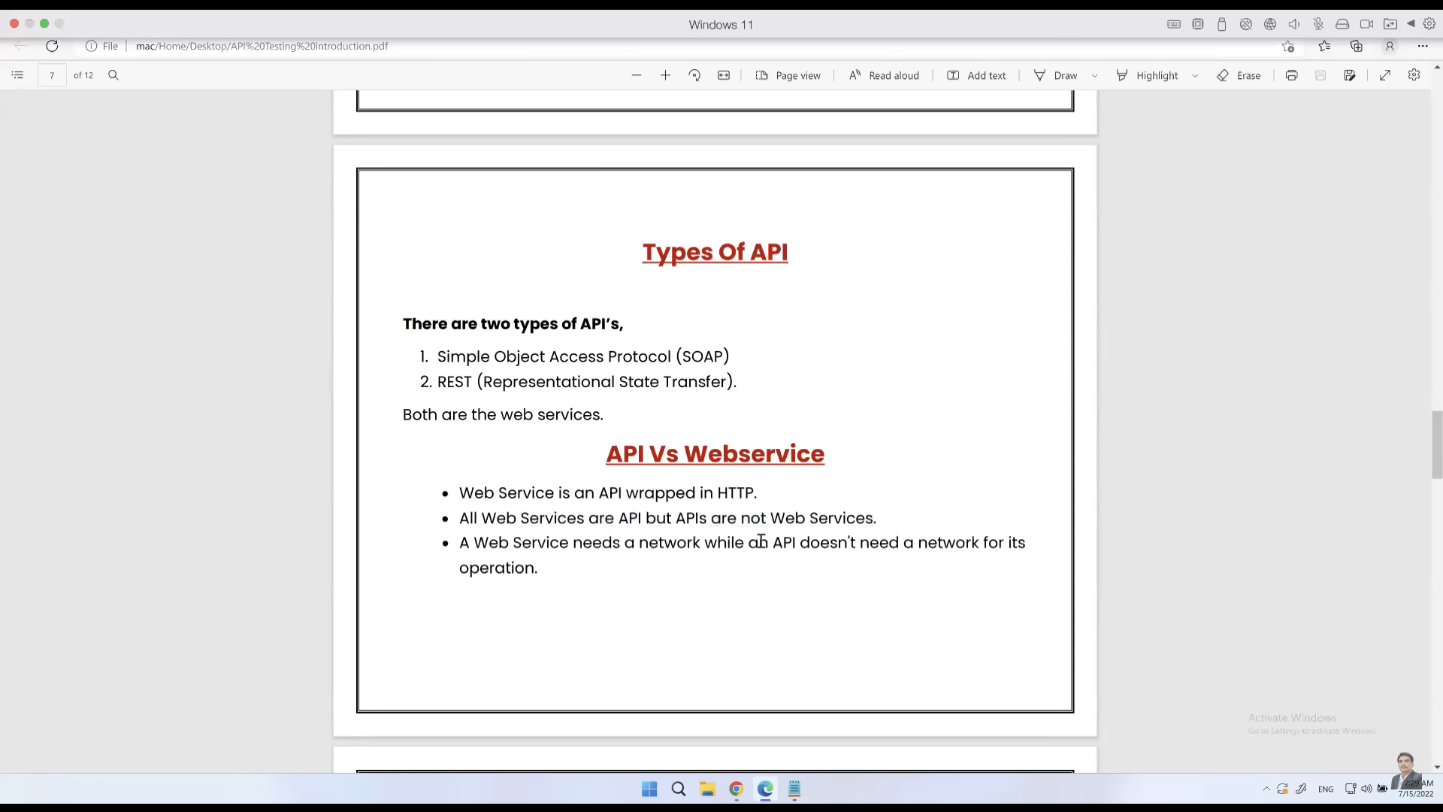

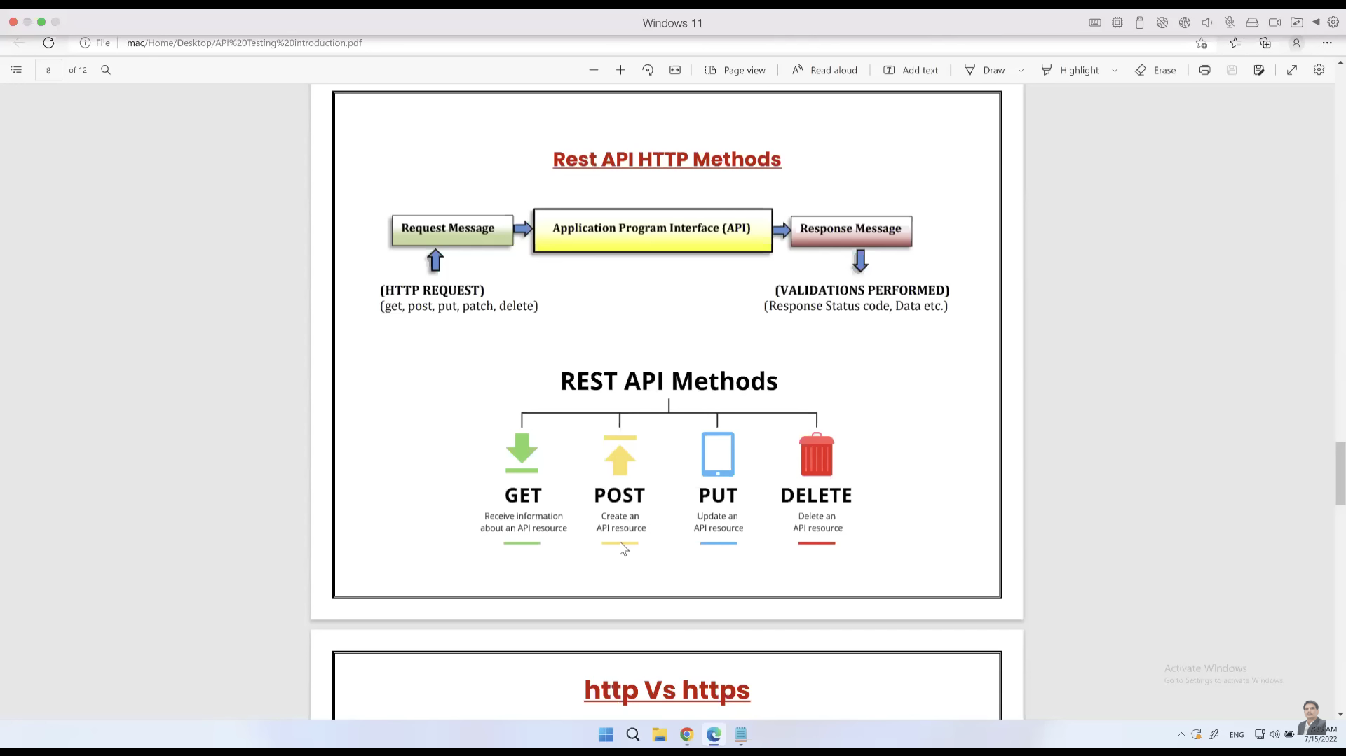

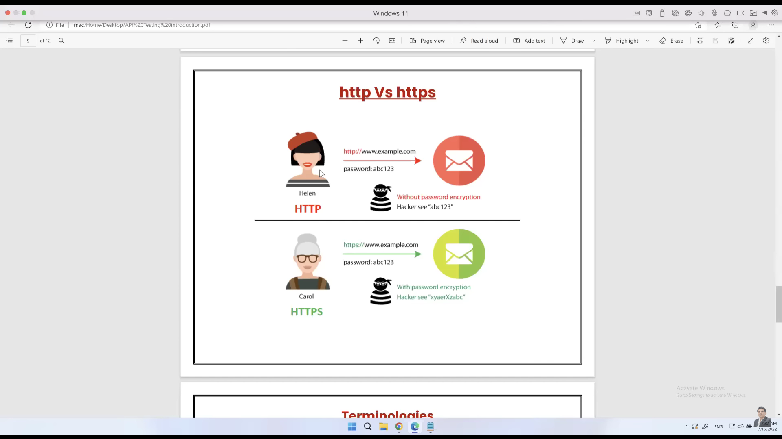

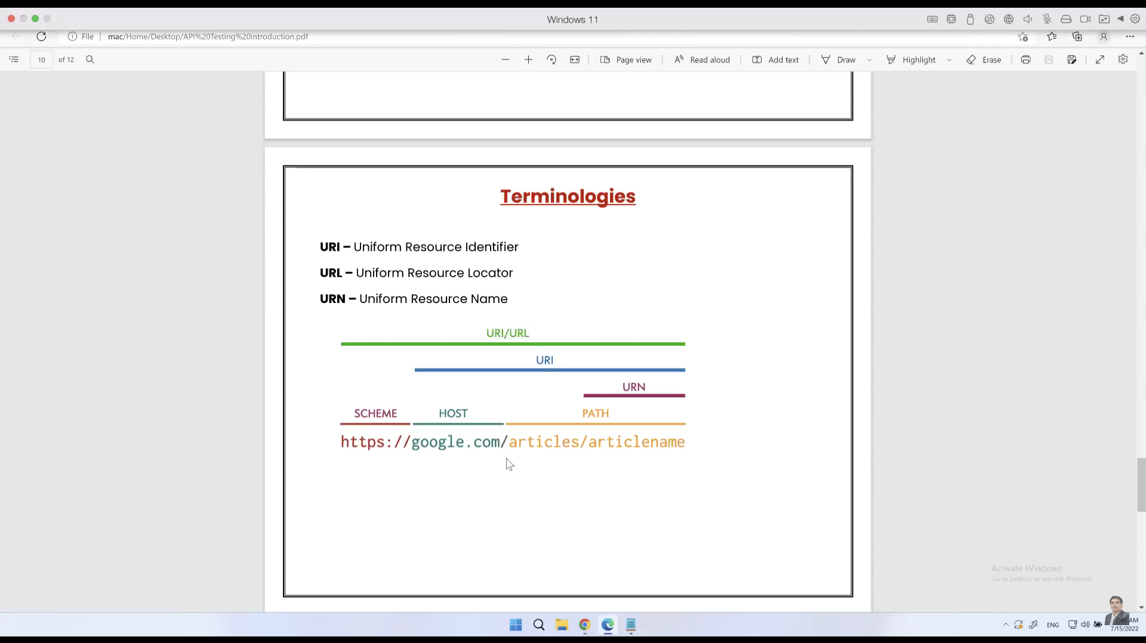

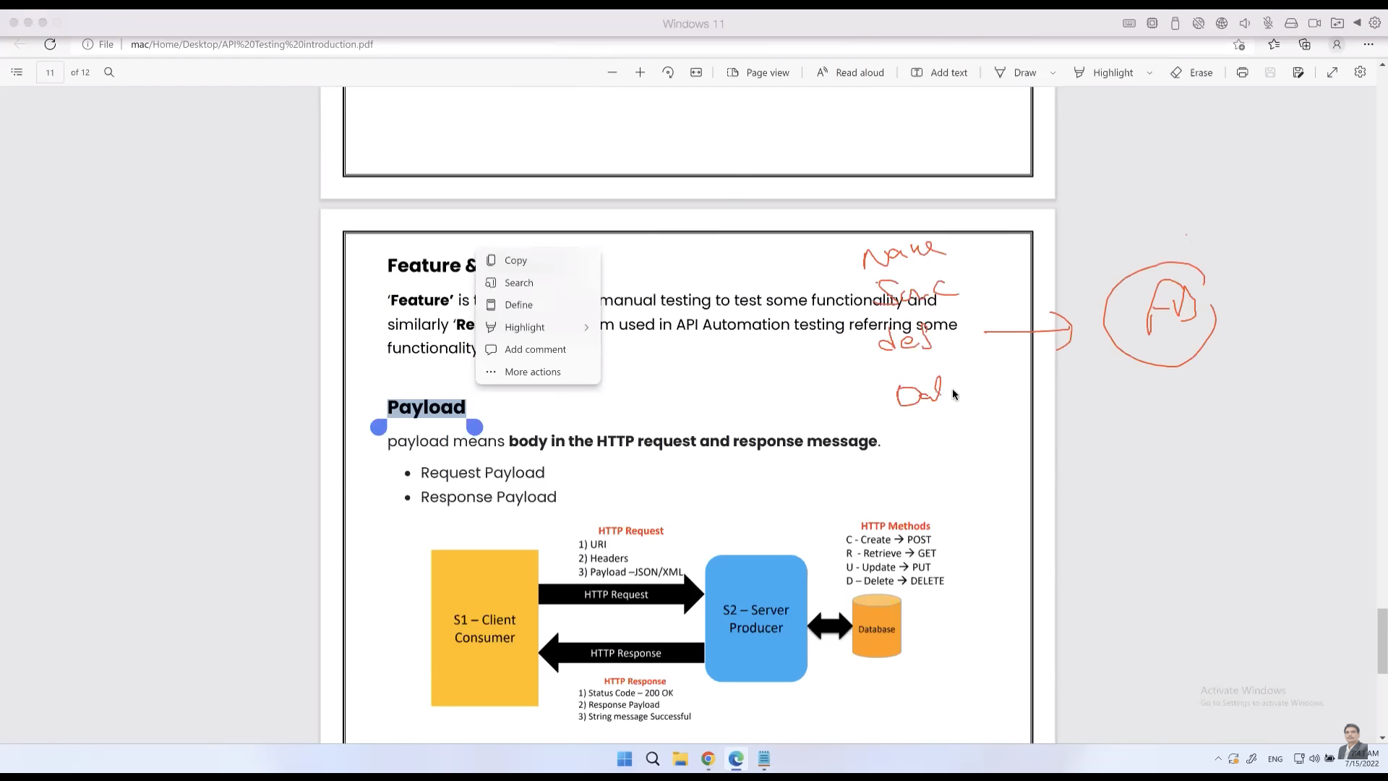

END